Autonomous Accident Detection and Emergency Communication System
Abstract
Road accidents are one of the leading causes of death and serious injury worldwide. In many cases, victims do not receive immediate medical assistance because accidents occur in remote areas or there are no witnesses to inform emergency services. The delay in providing medical attention often leads to increased fatalities and severe health complications. To address this problem, an Autonomous Accident Detection and Emergency Communication System can be implemented.
This system is designed to automatically detect road accidents using sensors and immediately send emergency alerts to predefined contacts or emergency services. The system uses a microcontroller connected to sensors such as an accelerometer and vibration sensor to detect sudden impacts or abnormal vehicle movements. When an accident is detected, a GPS module retrieves the vehicle's location, and a GSM module sends a text message containing the accident information and geographic coordinates to emergency contacts.
The main objective of this project is to reduce the time required for accident reporting and improve the chances of survival for accident victims. By integrating embedded systems and wireless communication technologies, the proposed system provides a reliable and cost-effective solution for accident detection and emergency response.

Introduction
Road transportation plays an essential role in modern society, enabling the movement of people and goods. However, the increasing number of vehicles on the road has also led to a significant rise in road accidents. According to global statistics, thousands of accidents occur every day due to overspeeding, driver fatigue, poor road conditions, and mechanical failures. One of the major challenges after an accident is the delay in reporting the incident to emergency services.
In many situations, victims are unable to call for help due to injuries or unconsciousness. Additionally, accidents that occur in isolated locations may go unnoticed for a long period of time. This delay in rescue operations can result in severe injuries or even death.
To solve this problem, an automated system that detects accidents and sends alerts instantly is necessary. The Autonomous Accident Detection and Emergency Communication System aims to provide such a solution. The system continuously monitors the vehicle’s motion and detects unusual movements or impacts. Once an accident is detected, it automatically sends the vehicle’s location to emergency contacts using wireless communication technology. This system can significantly reduce response time and improve road safety.

Objectives
The primary objectives of the Autonomous Accident Detection and Emergency Communication System are:
- To detect vehicle accidents automatically using sensors.
- To send emergency alerts immediately after accident detection.
- To provide accurate accident location using GPS technology.
- To reduce the delay in emergency response.
- To improve road safety using embedded system technology.
These objectives aim to create a reliable and efficient system that helps save lives by ensuring timely medical assistance.

Existing System
In the traditional accident reporting system, accidents are usually reported by eyewitnesses or by the victims themselves. This method is unreliable because it depends entirely on human intervention. If there are no witnesses nearby or if the victims are unable to communicate, the accident may remain unreported for a long time.
Another limitation of the existing system is the lack of accurate location information. Emergency responders often struggle to find the exact location of the accident, especially on highways or rural roads. This further delays rescue operations.
Therefore, the current accident reporting methods are inefficient and require an automated system that can detect accidents and send alerts without human involvement.

Proposed System
The proposed system automatically detects accidents and sends emergency notifications with location information. It uses sensors to monitor vehicle movement and identify sudden impacts that may indicate a collision.
When an accident occurs, the system immediately retrieves the location coordinates using a GPS module. These coordinates are then sent through a GSM module as a text message to predefined contacts such as family members, ambulance services, or police authorities.
The system operates continuously while the vehicle is in motion, ensuring real-time monitoring and quick response in case of an accident. The integration of sensors, microcontrollers, and communication modules makes the system efficient and reliable.

System Architecture
The system consists of several hardware components working together to detect accidents and send emergency alerts.
The main components include:
- Microcontroller (Arduino or ESP32)
- Accelerometer Sensor
- Vibration Sensor
- GPS Module
- GSM Module
- Power Supply
- Alert Buzzer
The sensors continuously monitor the motion and vibration of the vehicle. The microcontroller processes the sensor data and determines whether an accident has occurred. If the sensor values exceed predefined threshold levels, the system considers it as a possible accident.
After detecting the accident, the GPS module collects the vehicle's current location coordinates. The GSM module then sends an emergency message containing the accident alert and the GPS location to predefined phone numbers. This enables emergency responders to reach the accident location quickly.

Hardware Components
1. ESP32 Development Board
.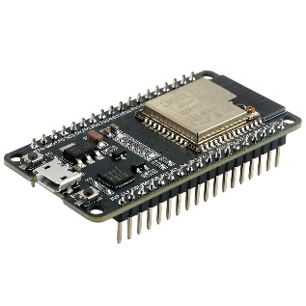
Purpose:
- Acts as the main microcontroller (brain of the system).
- Reads sensor data and controls all modules.
- Communicates with GPS, GSM, and MPU6050.
Features
- Built-in WiFi + Bluetooth
- Dual-core processor
- Multiple GPIO pins
- Supports serial communication

2. MPU6050 Accelerometer & Gyroscope Sensor:
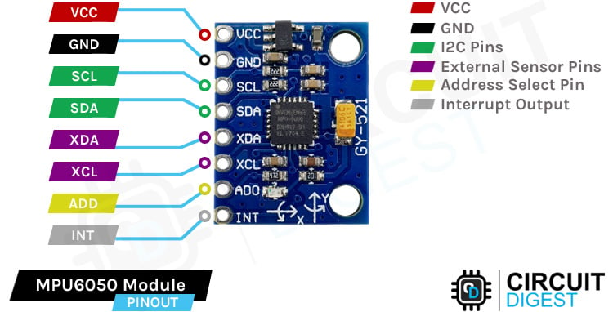

Purpose:
- Detects sudden motion, tilt, and acceleration.
- Used to identify accidents or collisions.
Functions
- 3-axis accelerometer
- 3-axis gyroscope
- Motion tracking

3. SIM800L GSM Module
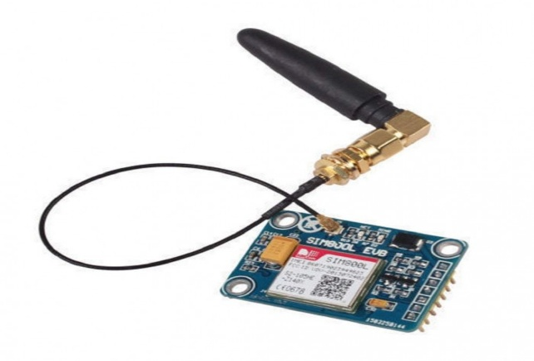

Purpose:
- Sends SMS alerts when an accident is detected.
Functions
- SMS sending
- Call alerts
- GPRS communication
Example message sent:
Accident Detected!
Location: https://maps.google.com/?q=17.3850,78.4867

4. NEO-6M GPS Module
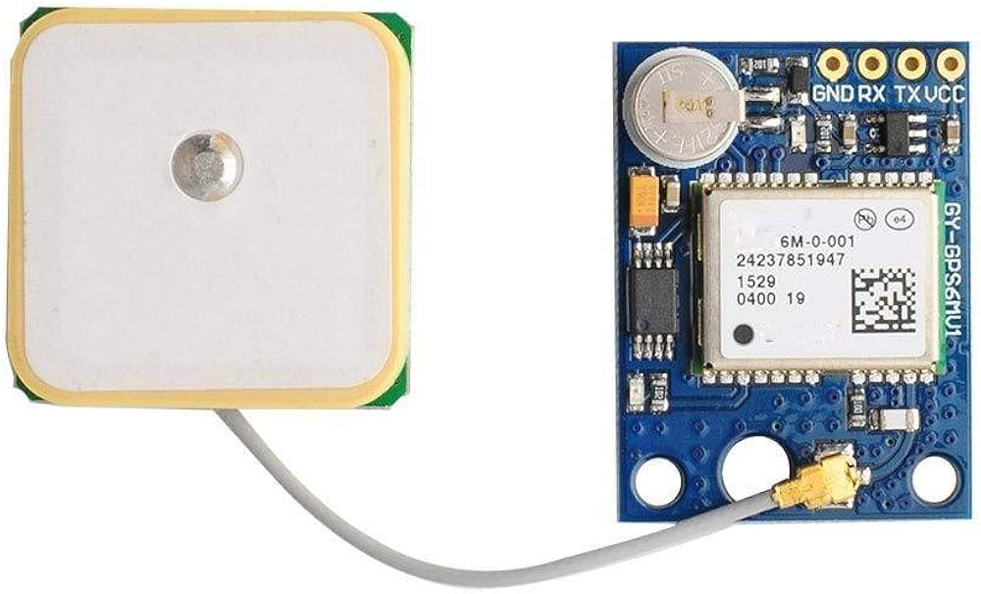

Purpose:
- Provides real-time latitude and longitude of the vehicle.
Functions
- Satellite communication
- Location tracking
- Speed calculation

5. L298N Motor Driver
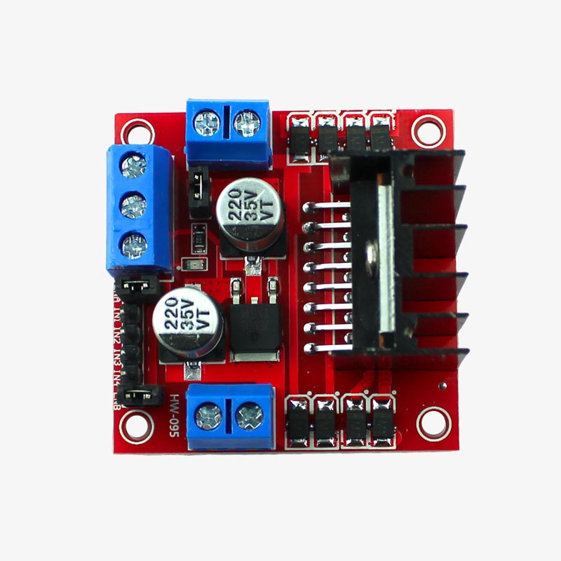

Purpose:
- Controls two DC motors.
Functions
- Motor direction control
- Speed control using PWM

6. DC Gear Motors (2 Motors)

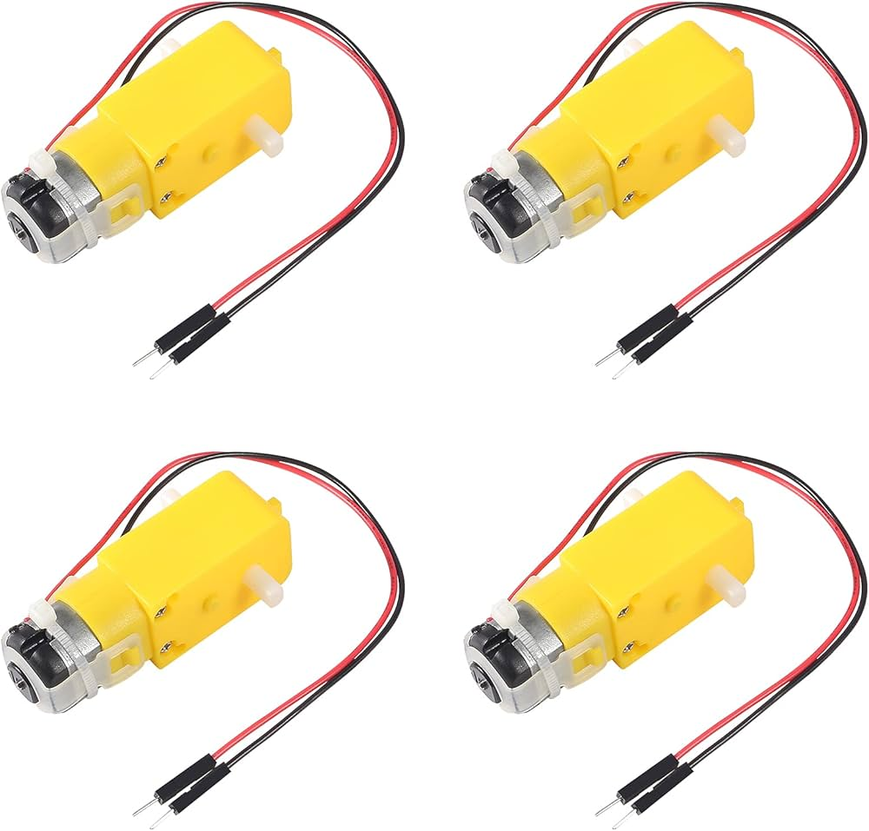
4
Purpose:
- Used to move the robot/vehicle prototype.

7. Li-ion Battery Pack (7.4V)



Purpose:
- Provides power supply to the system.
Output:
- 7.4V – 8.4V

8. Buzzer

4
Purpose:
- Gives audio alert when accident is detected.

Complete Components List
No | Component | Quantity
1 | ESP32 Development Board | 1
2 | MPU6050 Sensor | 1
3 | SIM800L GSM Module | 1
4 | NEO-6M GPS Module | 1
5 | L298N Motor Driver | 1
6 | DC Gear Motors | 2
7 | Li-ion Battery (7.4V) | 1
8 | Buzzer | 1
9 | Jumper Wires | Many
10 | Robot Chassis (optional) | 1

Software Requirements
The system requires software tools to program the microcontroller and manage communication between components. The main software requirements include:
- Arduino IDE for programming
- Embedded C or Arduino programming language
- GPS library for location tracking
- GSM library for sending SMS messages
- Serial communication protocols
The program continuously reads sensor data and checks for abnormal values that indicate an accident.

Working Principle
The working process of the system involves several steps. First, the sensors continuously monitor the movement and vibration of the vehicle. The microcontroller reads these sensor values and compares them with predefined threshold levels.
If the sensor values exceed the threshold, the system assumes that an accident has occurred. The GPS module then retrieves the current location coordinates of the vehicle. After obtaining the location data, the GSM module sends an emergency message to predefined contacts.
The message typically includes information such as:
- Accident alert notification
- GPS coordinates
- Vehicle identification details
This allows emergency services to quickly locate the accident site and provide assistance.

Advantages
The Autonomous Accident Detection and Emergency Communication System offers several advantages:
- Automatic accident detection without human intervention
- Faster emergency response time
- Accurate location tracking using GPS
- Cost-effective and easy to implement
- Improves road safety and reduces fatalities
These advantages make the system a valuable addition to modern vehicle safety technologies.

Applications
This system can be used in various applications, including:
- Smart vehicles and intelligent transportation systems
- Highway safety monitoring systems
- Emergency response systems
- Fleet management and logistics vehicles
- Smart city infrastructure
By integrating this system into vehicles, authorities can improve road safety and ensure faster rescue operations.

Future Enhancements
The system can be further improved by integrating advanced technologies. For example, IoT connectivity can allow real-time monitoring of accident data on cloud platforms. A mobile application can be developed to display accident alerts and location information instantly.
Artificial intelligence can also be used to analyze sensor data more accurately and reduce false accident detections. Another improvement could involve automatic ambulance dispatch systems that notify nearby hospitals and emergency services directly.
These enhancements would make the system more intelligent and efficient in saving lives.

Conclusion
Road accidents are a major global problem, and delayed emergency response often leads to severe consequences for victims. The Autonomous Accident Detection and Emergency Communication System provides an effective solution by automatically detecting accidents and sending immediate alerts with location information.
By using sensors, GPS technology, and GSM communication, the system ensures that emergency services are notified quickly. This reduces rescue time and increases the chances of survival for accident victims.
The implementation of such systems in vehicles can significantly improve road safety and support faster emergency response. With further advancements and integration with modern technologies, this system can become an essential feature in future transportation systems.

